EXPT NO:5B | DATA VISUALIZATION

AIM:
To visualize the Ocean Plastic Pollution dataset using Python and create different charts to understand student academic performance and identify important patterns.
PROCEDURE:
- Start the program.
- Import Pandas, Matplotlib, and Seaborn libraries.
- Load the Ocean Pollution CSV dataset.
- Display the first few records using head().
- Create a bar chart to compare different oceans based on Marine Debris.
- Create a pie chart to show the distribution of pollution records by Ocean.
- Create a line chart to analyze the relationship between Year and Oil Spill.
- Add suitable titles, axis labels, and legends.
- Display all the visualizations.
- Analyze the graphs and identify important patterns in the Ocean Pollution dataset.
- Stop the program.

CODE:
import pandas as pd
import matplotlib.pyplot as plt
import seaborn as sns
df = pd.read_csv("Ocean_Pollution_Dataset.csv")
print("First 5 Records:")
print(df.head())
ocean_debris = df.groupby(
"Ocean"
)["Marine_Debris_Tonnes"].mean()

plt.figure(figsize=(8, 5))

plt.bar(
ocean_debris.index,
ocean_debris.values
)

plt.title("Average Marine Debris by Ocean")
plt.xlabel("Ocean")
plt.ylabel("Marine Debris (Tonnes)")
plt.xticks(rotation=25)

plt.show()
ocean_counts = df["Ocean"].value_counts()

plt.figure(figsize=(7, 7))

plt.pie(
ocean_counts.values,
labels=ocean_counts.index,
autopct="%1.1f%%",
startangle=90
)

plt.title("Distribution of Ocean Pollution Records")

plt.show()
yearly_oil = df.groupby(
"Year"
)["Oil_Spill_Tonnes"].mean()

plt.figure(figsize=(8, 5))

plt.plot(
yearly_oil.index,
yearly_oil.values,
marker="o",
label="Oil Spill"
)

plt.title("Year-wise Average Oil Spill")
plt.xlabel("Year")
plt.ylabel("Oil Spill (Tonnes)")
plt.legend()
plt.grid(True)

plt.show()
print("\nAll visualizations displayed successfully.")
print("\n--- ANALYSIS ---")

print(
"Ocean with highest average Marine Debris:",
ocean_debris.idxmax()
)

print(
"Ocean with lowest average Marine Debris:",
ocean_debris.idxmin()
)

print(
"Year with highest average Oil Spill:",
yearly_oil.idxmax()
)

print(
"Highest average Oil Spill:",
yearly_oil.max(),
"Tonnes"
)

print(
"\nThe charts show differences in marine debris "
"and oil spill levels across oceans and years."
)
print("\nExperiment 5B completed successfully.")

OUTPUT:
First 5 Records:
Year Ocean Country Plastic_Waste_Tonnes Oil_Spill_Tonnes \
0 2015 Pacific Philippines 33795 1260
1 2015 Atlantic South Africa 62131 3319
2 2015 Indian China 80955 2833
3 2015 Arctic China 77150 589
4 2015 Southern India 49551 1928

Marine_Debris_Tonnes Water_Pollution_Index Microplastic_Level_mg_L \
0 47158 58.49 1.51
1 25023 62.26 1.62
2 14311 69.54 1.89
3 28118 69.29 1.68
4 20394 59.82 1.63

Affected_Marine_Species Cleanup_Cost_USD
0 104 19050
1 104 28579
2 93 30317
3 109 25154
4 102 20845
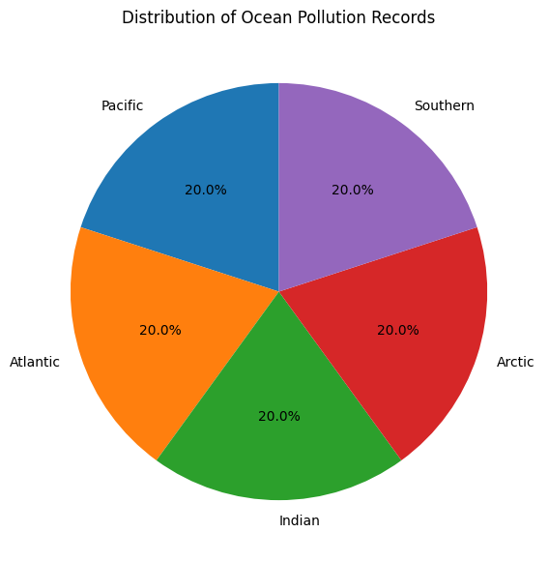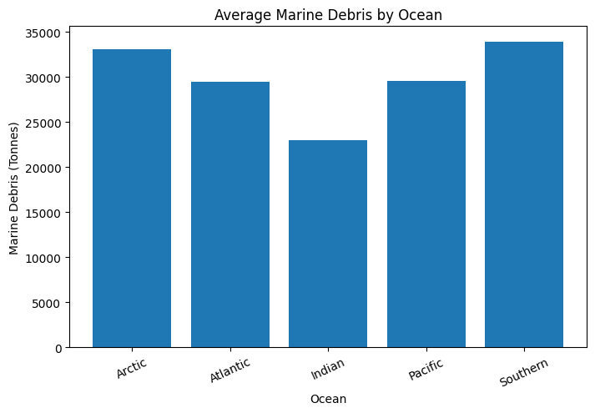

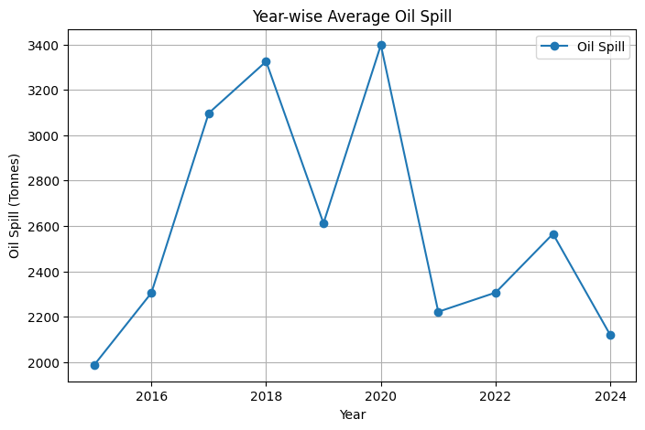

Result:

